**PROGRAM 6: Write a code to simulate Ping, Trace route Commands.**

**PING**

import java.io.*;

class pingserver {

    public static void main(String args[]) {

        try {

            String str;

            System.out.print(" Enter the IP Address to be Ping : ");

            BufferedReader buf1 = new BufferedReader(new InputStreamReader(System.in));

            String ip = buf1.readLine();

            Runtime H = Runtime.getRuntime();

            Process p = H.exec("ping " + ip);

            InputStream in = p.getInputStream();

            BufferedReader buf2 = new BufferedReader(new InputStreamReader(in));

            while ((str = buf2.readLine()) != null) {

                System.out.println(" " + str);

            }

        } catch (Exception e) {

            System.out.println(e.getMessage());

        }

    }

}

**OUTPUT**

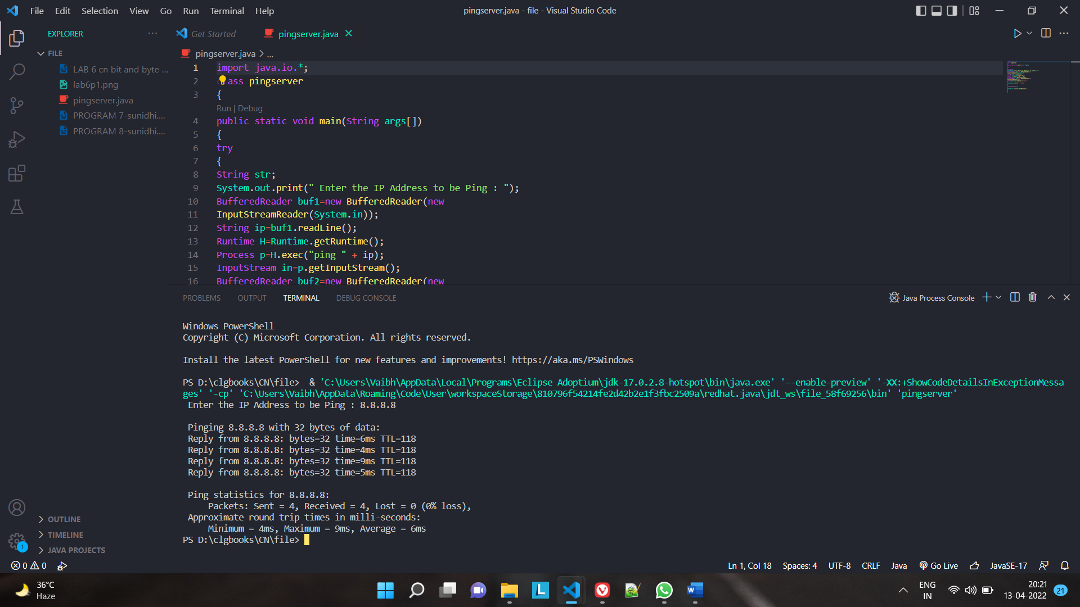

**TRACEROUTE**

import java.io.BufferedReader;

import java.io.InputStreamReader;

public class traceroutecmd {

    public static void runSystemCommand(String command) {

        try {

            Process p = Runtime.getRuntime().exec(command);

            BufferedReader inputStream = new BufferedReader(

                    new InputStreamReader(p.getInputStream()));

            String s = "";

            while ((s = inputStream.readLine()) != null)

                System.out.println(s);

        } catch (Exception e) {

        }

    }

    public static void main(String[] args) {

        String ip = "stackoverflow.com";

        runSystemCommand("tracert " + ip);

    }

}

**OUTPUT**

